COURIER MANAGEMENT SYSTEM

P.RISHITHA(031) K.SAHITHI(033) N.RAMYA(304)

**CONTENTS**

**1. Introduction**

**1.1 Purpose**

**1.2 intended audience**

**1.3 project scope**

**2. Project Description**

**3. Technology**

**3.1 Overview of technology**

**3.2 Software requirement**

**3.3 Hardware requirement**

**4.Database**

**5. Code templates**

**6. Output Screens**

**7. Conclusion & Future scope**

ABSTRACT:

This idea of project represents the ‘courier management system ’.The system is being used for day to day activities such as maintain employee details,booking a courier,maintain hub details, maintain company details,process data of employees and many other things.

1.INTRODUCTION

1.1 PURPOSE

This project deals with the ‘online shipping services’. The system will be used for day to day activities like out return, company details, hub rates,booking, non delivery, and pickup centers .Actually It is not easy to do this process manually because it would become very hectic. Hence it is recommended to automate the process by developing the relevant software as the world is moving from manual working to information and technology era where computerization becomes important in all walks of life.

1.2 INTENDED AUDIENCE AND READING

     This project is a prototype for the online shipping services and it is restricted within the college premises. This has been implemented under the guidance of college professors. This project is useful for the shipping services team and as well as to the customers.

1.3 project scope

    The purpose of the online shipping services is to ease courier management and to create a convenient and easy-to-use application for customers, trying to book courier shipping online. The system is based on a relational database with its courier management and reservation functions. We will havea database server supporting hundreds of major cities within India . Above all, we hope to provide a comfortable user experience along with the best pricing available.

2. OVERALL PROJECT DISCRIPTION

2.1 product perspective

A distributed shipping data base system stores the following information

Shipping details:

It includes the originating courier terminal and destination terminal.

Customer description:

It includes customer code , name ,address and phone number .this information may be used for keeping the records of the customer for updating the tracking details of the courier.

3.TECHNOLOGY

3.1 OVERVIEW OF TECHNOLOGY

Java programming language was originally developed by Sun Microsystems which

was initiated by James Gosling and released in 1995 as core component of Sun

Microsystems; Java platform (Java 1.0 [J2SE]).

The latest release of the Java Standard Edition is Java SE 8. With the advancement of Java

and its widespread popularity, multiple configurations were built to suit various types of

platforms. For example: J2EE for Enterprise Applications, J2ME for Mobile Applications.

The new J2 versions were renamed as Java SE, Java EE, and Java ME respectively. Java is

guaranteed to be Write Once, Run Anywhere.

Java is –

Object Oriented − In Java, everything is an Object. Java can be easily extended since it is

based on the Object model.

Platform Independent − Unlike many other programming languages including C and C++,

when Java is compiled, it is not compiled into platform specific machine, rather into

platform independent byte code. This byte code is distributed over the web and interpreted

by the Virtual Machine (JVM) on whichever platform it is being run on.

Simple − Java is designed to be easy to learn. If you understand the basic concept of OOP

Java, it would be easy to master.

Secure − With Java secure feature it enables to develop virus-free, tamper-free

systems. Authentication techniques are based on public-key encryption.

Architecture-neutral − Java compiler generates an architecture-neutral object file format,

which makes the compiled code executable on many processors, with the presence of Java

runtime system.

Portable − Being architecture-neutral and having no implementation dependent aspects of

the specification makes Java portable. Compiler in Java is written in ANSI C with a clean

portability boundary, which is a POSIX subset.

Robust − Java makes an effort to eliminate error prone situations by emphasizing mainly on

compile time error checking and runtime checking.

Multithreaded − With Java’s multithreaded feature it is possible to write programs that

can perform many tasks simultaneously. This design feature allows the developers to

construct interactive applications that can run smoothly.

Interpreted − Java byte code is translated on the fly to native machine instructions and is

not stored anywhere. The development process is more rapid and analytical since the

linking is an incremental and light-weight process.

High Performance − With the use of Just-In-Time compilers, Java enables high performance.

Distributed Java is designed for the distributed environment of the internet.

Dynamic − Java is considered to be more dynamic than C or C++ since it is designed to adapt

to an evolving environment. Java programs can carry extensive amount of run-time

information that can be used to verify and resolve accesses to objects on run-time.

A relational Database Management System(RDBMS) is a database management

system that is based on the relational model as introduced by Dr. Edgar F. Codd. An

important feature of relational systems is that a single database can be spread across

several tables.

In RDBMS, relationship between two tables can be specified at the time of table creation.

Most of the RDBMS support Client/Server Architecture and Distributed databases. RDBMS

also implements multiple levels of security.

Most RDBMS usually satisfy more than 7 or 8 rules of Dr. E F Codd. SQL is a language that

provides an interface to relational database systems. SQL was developed by IBM in the

1970s. In common usage SQL encompasses DDL, DML, TCL and DCL commands used for data

structure definition, data manipulation, transaction control and data/authorization control.

Typically, software applications are written in a specific programming language (such as

Java, C#, etc.) while databases accept queries in some other database specific language

(such as SQL).

Therefore, when a software application needs to access data in a database, application

programmers need to learn and incorporate database specific languages within their

applications.

ODBC (Open Database Connectivity) and JDBC (Java DataBase Connectivity) are two API

(application program interface ) that solve this specific problem.

They are interfaces that can translate languages to each other (application and database)

ODBC and JDBC achieve portability. All direct interaction with a specific DBMS happens

through a DBMS specific driver. A driver is a software program that translates the ODBC or

JDBC calls into DBMS specific calls.

3.2 Software Requirements

Any basic JAVA compiler such a GCC compiler or Oracle software or any other which

supports java.

3.3 Hardware Requirements

Processor: Pentium 233 MHz

Ram: 32 MB

Hard disk: 2.1GB

Floppy Drive: 1.44 MB

Keyboard: 105 standard

4.DATABASE TABLES:

Customer Table.

SQL> create table customer(cust_id number(10) primary key,cust_name varchar2(20) not null,cust_ph number(10) not null unique,cust_mail varchar2(100) not null unique);

Table created.

SQL> insert into customer values(&cust_id,'&cust_name',&cust_ph,'&cust_mail');

Enter value for cust_id: 1001

Enter value for cust_name: shreya

Enter value for cust_ph: 9010586970

Enter value for cust_mail: shreya@gmail.com

old 1: insert into customer values(&cust_id,'&cust_name',&cust_ph,'&cust_mail')

new 1: insert into customer values(1001,'shreya',9010586970,'shreya@gmail.com')

1 row created.

SQL> /

Enter value for cust_id: 1002

Enter value for cust_name: poojitha

Enter value for cust_ph: 9441477944

Enter value for cust_mail: poojitha@gmail.com

old 1: insert into customer values(&cust_id,'&cust_name',&cust_ph,'&cust_mail')

new 1: insert into customer values(1002,'poojitha',9441477944,'poojitha@gmail.com')

1 row created.

SQL> /

Enter value for cust_id: 1003

Enter value for cust_name: deeksha

Enter value for cust_ph: 9985763322

Enter value for cust_mail: deeksha@gmail.com

old 1: insert into customer values(&cust_id,'&cust_name',&cust_ph,'&cust_mail')

new 1: insert into customer values(1003,'deeksha',9985763322,'deeksha@gmail.com')

1 row created.

SQL> /

Enter value for cust_id: 1004

Enter value for cust_name: priyanka

Enter value for cust_ph: 9441677944

Enter value for cust_mail: priyanka@gmail.com

old 1: insert into customer values(&cust_id,'&cust_name',&cust_ph,'&cust_mail')

new 1: insert into customer values(1004,'priyanka',9441677944,'priyanka@gmail.com')

1 row created.

SQL> /

Enter value for cust_id: 1005

Enter value for cust_name: rithvika

Enter value for cust_ph: 9050586970

Enter value for cust_mail: rithvika@gmail.com

old 1: insert into customer values(&cust_id,'&cust_name',&cust_ph,'&cust_mail')

new 1: insert into customer values(1005,'rithvika',9050586970,'rithvika@gmail.com')

1 row created.

SQL> /

Enter value for cust_id: 1006

Enter value for cust_name: abhiram

Enter value for cust_ph: 9441794412

Enter value for cust_mail: abhiram@gmail.com

old 1: insert into customer values(&cust_id,'&cust_name',&cust_ph,'&cust_mail')

new 1: insert into customer values(1006,'abhiram',9441794412,'abhiram@gmail.com')

1 row created.

SQL> /

Enter value for cust_id: 1007

Enter value for cust_name: priyadharshan

Enter value for cust_ph: 9974566944

Enter value for cust_mail: priyadharshan@gmail.com

old 1: insert into customer values(&cust_id,'&cust_name',&cust_ph,'&cust_mail')

new 1: insert into customer values(1007,'priyadharshan',9974566944,'priyadharshan@gmail.com')

1 row created.

SQL> /

Enter value for cust_id: 1008

Enter value for cust_name: rishithaa

Enter value for cust_ph: 7673927877

Enter value for cust_mail: rishithaa@gmail.com

old 1: insert into customer values(&cust_id,'&cust_name',&cust_ph,'&cust_mail')

new 1: insert into customer values(1008,'rishithaa',7673927877,'rishithaa@gmail.com')

1 row created.

SQL> /

Enter value for cust_id: 1009

Enter value for cust_name: prasanna

Enter value for cust_ph: 1239874598

Enter value for cust_mail: prasanna@gmail.com

old 1: insert into customer values(&cust_id,'&cust_name',&cust_ph,'&cust_mail')

new 1: insert into customer values(1009,'prasanna',1239874598,'prasanna@gmail.com')

1 row created.

SQL> /

Enter value for cust_id: 1010

Enter value for cust_name: raghuram

Enter value for cust_ph: 1209674523

Enter value for cust_mail: raghuram@gmail.com

old 1: insert into customer values(&cust_id,'&cust_name',&cust_ph,'&cust_mail')

new 1: insert into customer values(1010,'raghuram',1209674523,'raghuram@gmail.com')

1 row created.

SQL> /

Enter value for cust_id: 1011

Enter value for cust_name: vivek

Enter value for cust_ph: 9987564457

Enter value for cust_mail: vivek@gmail.com

old 1: insert into customer values(&cust_id,'&cust_name',&cust_ph,'&cust_mail')

new 1: insert into customer values(1011,'vivek',9987564457,'vivek@gmail.com')

1 row created.

SQL> /

Enter value for cust_id: 1012

Enter value for cust_name: chaithanya

Enter value for cust_ph: 1209349567

Enter value for cust_mail: chaithanya@gmail.com

old 1: insert into customer values(&cust_id,'&cust_name',&cust_ph,'&cust_mail')

new 1: insert into customer values(1012,'chaithanya',1209349567,'chaithanya@gmail.com')

1 row created.

SQL> /

Enter value for cust_id: 1013

Enter value for cust_name: preethi

Enter value for cust_ph: 9977885566

Enter value for cust_mail: preethi@gmail.com

old 1: insert into customer values(&cust_id,'&cust_name',&cust_ph,'&cust_mail')

new 1: insert into customer values(1013,'preethi',9977885566,'preethi@gmail.com')

1 row created.

SQL> /

Enter value for cust_id: 1014

Enter value for cust_name: mounika

Enter value for cust_ph: 1177229955

Enter value for cust_mail: mounika@gmail.com

old 1: insert into customer values(&cust_id,'&cust_name',&cust_ph,'&cust_mail')

new 1: insert into customer values(1014,'mounika',1177229955,'mounika@gmail.com')

1 row created.

SQL> /

Enter value for cust_id: 1015

Enter value for cust_name: vishnu

Enter value for cust_ph: 2299115588

Enter value for cust_mail: vishnu@gmail.com

old 1: insert into customer values(&cust_id,'&cust_name',&cust_ph,'&cust_mail')

new 1: insert into customer values(1015,'vishnu',2299115588,'vishnu@gmail.com')

1 row created.

SQL> /

Enter value for cust_id: 1016

Enter value for cust_name: malla Reddy

Enter value for cust_ph: 1199226677

Enter value for cust_mail: mallareddy@gmail.com

old 1: insert into customer values(&cust_id,'&cust_name',&cust_ph,'&cust_mail')

new 1: insert into customer values(1016,'malla Reddy',1199226677,'mallareddy@gmail.com')

1 row created.

SQL> /

Enter value for cust_id: 1017

Enter value for cust_name: radhika

Enter value for cust_ph: 2277664488

Enter value for cust_mail: radhikareddy@gmail.com

old 1: insert into customer values(&cust_id,'&cust_name',&cust_ph,'&cust_mail')

new 1: insert into customer values(1017,'radhika',2277664488,'radhikareddy@gmail.com')

1 row created.

SQL> /

Enter value for cust_id: 1018

Enter value for cust_name: vijay

Enter value for cust_ph: 1155772299

Enter value for cust_mail: vijay@gmail.com

old 1: insert into customer values(&cust_id,'&cust_name',&cust_ph,'&cust_mail')

new 1: insert into customer values(1018,'vijay',1155772299,'vijay@gmail.com')

1 row created.

SQL> /

Enter value for cust_id: 1019

Enter value for cust_name: mona Sree

Enter value for cust_ph: 5544338899

Enter value for cust_mail: monasree@gmail.com

old 1: insert into customer values(&cust_id,'&cust_name',&cust_ph,'&cust_mail')

new 1: insert into customer values(1019,'mona Sree',5544338899,'monasree@gmail.com')

1 row created.

SQL> /

Enter value for cust_id: 1020

Enter value for cust_name: yamigautham

Enter value for cust_ph: 2299551188

Enter value for cust_mail: yamigautham@gmail.com

old 1: insert into customer values(&cust_id,'&cust_name',&cust_ph,'&cust_mail')

new 1: insert into customer values(1020,'yamigautham',2299551188,'yamigautham@gmail.com')

1 row created.

SQL> commit;

Commit complete.

SQL> spool off;SQL> desc table customer;

Usage: DESCRIBE [schema.]object[@db_link]

SQL> desc customer;

Name Null? Type

----------------------------------------- -------- ----------------------------

CUST_ID NOT NULL NUMBER(10)

CUST_NAME NOT NULL VARCHAR2(20)

CUST_PH NOT NULL NUMBER(10)

CUST_MAIL NOT NULL VARCHAR2(100)

SQL> insert into customer values(&cust_id,'&cust_name',&cust_ph,'&cust_mail');

Enter value for cust_id: 1021

Enter value for cust_name: swaroop

Enter value for cust_ph: 9058869803

Enter value for cust_mail: swaroop@gmail.com

old 1: insert into customer values(&cust_id,'&cust_name',&cust_ph,'&cust_mail')

new 1: insert into customer values(1021,'swaroop',9058869803,'swaroop@gmail.com')

1 row created.

SQL> /

Enter value for cust_id: 1022

Enter value for cust_name: anuroop reddy

Enter value for cust_ph: 2233009977

Enter value for cust_mail: anuroopreddy@gmail.com

old 1: insert into customer values(&cust_id,'&cust_name',&cust_ph,'&cust_mail')

new 1: insert into customer values(1022,'anuroop reddy',2233009977,'anuroopreddy@gmail.com')

1 row created.

SQL> /

Enter value for cust_id: 1023

Enter value for cust_name: tharun kiran

Enter value for cust_ph: 3311002200

Enter value for cust_mail: tharunkiran@gmail.com

old 1: insert into customer values(&cust_id,'&cust_name',&cust_ph,'&cust_mail')

new 1: insert into customer values(1023,'tharun kiran',3311002200,'tharunkiran@gmail.com')

1 row created.

SQL> /

Enter value for cust_id: 1024

Enter value for cust_name: vishal reddy

Enter value for cust_ph: 2200118899

Enter value for cust_mail: vishalreddy@gmail.com

old 1: insert into customer values(&cust_id,'&cust_name',&cust_ph,'&cust_mail')

new 1: insert into customer values(1024,'vishal reddy',2200118899,'vishalreddy@gmail.com')

1 row created.

SQL> /

Enter value for cust_id: 1025

Enter value for cust_name: thriviram goud

Enter value for cust_ph: 1100990088

Enter value for cust_mail: thriviramgoud@gmail.com

old 1: insert into customer values(&cust_id,'&cust_name',&cust_ph,'&cust_mail')

new 1: insert into customer values(1025,'thriviram goud',1100990088,'thriviramgoud@gmail.com')

1 row created.

SQL> /

Enter value for cust_id: 1026

Enter value for cust_name: karan reddy

Enter value for cust_ph: 1111009966

Enter value for cust_mail: karanreddy@gmail.com

old 1: insert into customer values(&cust_id,'&cust_name',&cust_ph,'&cust_mail')

new 1: insert into customer values(1026,'karan reddy',1111009966,'karanreddy@gmail.com')

1 row created.

SQL> /

Enter value for cust_id: 1027

Enter value for cust_name: jagadish

Enter value for cust_ph: 1100229933

Enter value for cust_mail: jagadish@gmail.com

old 1: insert into customer values(&cust_id,'&cust_name',&cust_ph,'&cust_mail')

new 1: insert into customer values(1027,'jagadish ',1100229933,'jagadish@gmail.com')

1 row created.

SQL> /

Enter value for cust_id: 1028

Enter value for cust_name: pavithra patel

Enter value for cust_ph: 2200990088

Enter value for cust_mail: pavithrapatel@gmail.com

old 1: insert into customer values(&cust_id,'&cust_name',&cust_ph,'&cust_mail')

new 1: insert into customer values(1028,'pavithra patel',2200990088,'pavithrapatel@gmail.com')

1 row created.

SQL> /

Enter value for cust_id: 1029

Enter value for cust_name: jamaithra kiran

Enter value for cust_ph: 7788996600

Enter value for cust_mail: jamaithrakiran@gmail.com

old 1: insert into customer values(&cust_id,'&cust_name',&cust_ph,'&cust_mail')

new 1: insert into customer values(1029,'jamaithra kiran',7788996600,'jamaithrakiran@gmail.com')

1 row created.

SQL> /

Enter value for cust_id: 1030

Enter value for cust_name: ayushman kurrana

Enter value for cust_ph: 7899067876

Enter value for cust_mail: ayushmankurrana@gmail.com

old 1: insert into customer values(&cust_id,'&cust_name',&cust_ph,'&cust_mail')

new 1: insert into customer values(1030,'ayushman kurrana',7899067876,'ayushmankurrana@gmail.com')

1 row created.

COURIER TABLE.

SQL> create table courier(cou_id number(10) primary key,cou_weight number(5) not null,pickup_add varchar2(10) not null,destin_add varchar2(10) not null);

Table created.

SQL> insert into courier values(&cou_id,&cou_weight,'&pickup_add','&destin_add');

Enter value for cou_id: 11

Enter value for cou_weight: 5

Enter value for pickup_add: A

Enter value for destin_add: B

old 1: insert into courier values(&cou_id,&cou_weight,'&pickup_add','&destin_add')

new 1: insert into courier values(11,5,'A','B')

1 row created.

SQL> /

Enter value for cou_id: 12

Enter value for cou_weight: 3

Enter value for pickup_add: A

Enter value for destin_add: P

old 1: insert into courier values(&cou_id,&cou_weight,'&pickup_add','&destin_add')

new 1: insert into courier values(12,3,'A','P')

1 row created.

SQL> /

Enter value for cou_id: 13

Enter value for cou_weight: 23

Enter value for pickup_add: S

Enter value for destin_add: O

old 1: insert into courier values(&cou_id,&cou_weight,'&pickup_add','&destin_add')

new 1: insert into courier values(13,23,'S','O')

1 row created.

SQL> /

Enter value for cou_id: 14

Enter value for cou_weight: 67

Enter value for pickup_add: D

Enter value for destin_add: P

old 1: insert into courier values(&cou_id,&cou_weight,'&pickup_add','&destin_add')

new 1: insert into courier values(14,67,'D','P')

1 row created.

SQL> /

Enter value for cou_id: 15

Enter value for cou_weight: 234

Enter value for pickup_add: E

Enter value for destin_add: R

old 1: insert into courier values(&cou_id,&cou_weight,'&pickup_add','&destin_add')

new 1: insert into courier values(15,234,'E','R')

1 row created.

SQL> /

Enter value for cou_id: 16

Enter value for cou_weight: 907

Enter value for pickup_add: T

Enter value for destin_add: U

old 1: insert into courier values(&cou_id,&cou_weight,'&pickup_add','&destin_add')

new 1: insert into courier values(16,907,'T','U')

1 row created.

SQL> /

Enter value for cou_id: 17

Enter value for cou_weight: 6780

Enter value for pickup_add: Y

Enter value for destin_add: I

old 1: insert into courier values(&cou_id,&cou_weight,'&pickup_add','&destin_add')

new 1: insert into courier values(17,6780,'Y','I')

1 row created.

SQL> /

Enter value for cou_id: 18

Enter value for cou_weight: 457

Enter value for pickup_add: Y

Enter value for destin_add: O

old 1: insert into courier values(&cou_id,&cou_weight,'&pickup_add','&destin_add')

new 1: insert into courier values(18,457,'Y','O')

1 row created.

SQL> /

Enter value for cou_id: 19

Enter value for cou_weight: 234

Enter value for pickup_add: U

Enter value for destin_add: I

old 1: insert into courier values(&cou_id,&cou_weight,'&pickup_add','&destin_add')

new 1: insert into courier values(19,234,'U','I')

1 row created.

SQL> /

Enter value for cou_id: 20

Enter value for cou_weight: 3456

Enter value for pickup_add: I

Enter value for destin_add: O

old 1: insert into courier values(&cou_id,&cou_weight,'&pickup_add','&destin_add')

new 1: insert into courier values(20,3456,'I','O')

1 row created.

SQL> /

Enter value for cou_id: 21

Enter value for cou_weight: 768

Enter value for pickup_add: R

Enter value for destin_add: P

old 1: insert into courier values(&cou_id,&cou_weight,'&pickup_add','&destin_add')

new 1: insert into courier values(21,768,'R','P')

1 row created.

SQL> /

Enter value for cou_id: 22

Enter value for cou_weight: 6789

Enter value for pickup_add: P

Enter value for destin_add: F

old 1: insert into courier values(&cou_id,&cou_weight,'&pickup_add','&destin_add')

new 1: insert into courier values(22,6789,'P','F')

1 row created.

SQL> /

Enter value for cou_id: 23

Enter value for cou_weight: 123

Enter value for pickup_add: T

Enter value for destin_add: U

old 1: insert into courier values(&cou_id,&cou_weight,'&pickup_add','&destin_add')

new 1: insert into courier values(23,123,'T','U')

1 row created.

SQL> /

Enter value for cou_id: 24

Enter value for cou_weight: 456

Enter value for pickup_add: T

Enter value for destin_add: I

old 1: insert into courier values(&cou_id,&cou_weight,'&pickup_add','&destin_add')

new 1: insert into courier values(24,456,'T','I')

1 row created.

SQL> /

Enter value for cou_id: 25

Enter value for cou_weight: 1245

Enter value for pickup_add: E

Enter value for destin_add: W

old 1: insert into courier values(&cou_id,&cou_weight,'&pickup_add','&destin_add')

new 1: insert into courier values(25,1245,'E','W')

1 row created.

SQL> /

Enter value for cou_id: 26

Enter value for cou_weight: 456

Enter value for pickup_add: C

Enter value for destin_add: V

old 1: insert into courier values(&cou_id,&cou_weight,'&pickup_add','&destin_add')

new 1: insert into courier values(26,456,'C','V')

1 row created.

SQL> /

Enter value for cou_id: 27

Enter value for cou_weight: 4567

Enter value for pickup_add: M

Enter value for destin_add: N

old 1: insert into courier values(&cou_id,&cou_weight,'&pickup_add','&destin_add')

new 1: insert into courier values(27,4567,'M','N')

1 row created.

SQL> /

Enter value for cou_id: 28

Enter value for cou_weight: 12234

Enter value for pickup_add: C

Enter value for destin_add: B

old 1: insert into courier values(&cou_id,&cou_weight,'&pickup_add','&destin_add')

new 1: insert into courier values(28,12234,'C','B')

1 row created.

SQL> /

Enter value for cou_id: 29

Enter value for cou_weight: 9087

Enter value for pickup_add: C

Enter value for destin_add: U

old 1: insert into courier values(&cou_id,&cou_weight,'&pickup_add','&destin_add')

new 1: insert into courier values(29,9087,'C','U')

1 row created.

SQL> /

Enter value for cou_id: 30

Enter value for cou_weight: 3456

Enter value for pickup_add: N

Enter value for destin_add: O

old 1: insert into courier values(&cou_id,&cou_weight,'&pickup_add','&destin_add')

new 1: insert into courier values(30,3456,'N','O')

1 row created.

SQL> select * from courier;

COU_ID COU_WEIGHT PICKUP_ADD DESTIN_ADD

---------- ---------- ---------- ----------

11 5 A B

12 3 A P

13 23 S O

14 67 D P

15 234 E R

16 907 T U

17 6780 Y I

18 457 Y O

19 234 U I

20 3456 I O

21 768 R P

COU_ID COU_WEIGHT PICKUP_ADD DESTIN_ADD

---------- ---------- ---------- ----------

22 6789 P F

23 123 T U

24 456 T I

25 1245 E W

26 456 C V

27 4567 M N

28 12234 C B

29 9087 C U

30 3456 N O

20 rows selected.

SQL> commit;

Commit complete.

SQL> spool off;

EMPLOYEE TABLE.

SQL> create table empolyee(emp_id number(10) primary key,emp_name varchar2(20) not null,emp_ph number(10) not null unique,emp_mail varchar2(100) not null unique);

Table created.

SQL> spool off;

SQL> insert into empolyee values(&emp_id,'&emp_name',&emp_ph,'&emp_mail');

Enter value for emp_id: 111111

Enter value for emp_name: riya chowdry

Enter value for emp_ph: 1177225599

Enter value for emp_mail: riyachowdry@gmail.com

old 1: insert into empolyee values(&emp_id,'&emp_name',&emp_ph,'&emp_mail')

new 1: insert into empolyee values(111111,'riya chowdry',1177225599,'riyachowdry@gmail.com')

1 row created.

SQL> /

Enter value for emp_id: 111112

Enter value for emp_name: agio chowdry

Enter value for emp_ph: 2288336677

Enter value for emp_mail: agiochowdry@courier.com

old 1: insert into empolyee values(&emp_id,'&emp_name',&emp_ph,'&emp_mail')

new 1: insert into empolyee values(111112,'agio chowdry',2288336677,'agiochowdry@courier.com')

1 row created.

SQL> /

Enter value for emp_id: 111113

Enter value for emp_name: vinav Reddy

Enter value for emp_ph: 2288335577

Enter value for emp_mail: vinavreddy@gmail.com

old 1: insert into empolyee values(&emp_id,'&emp_name',&emp_ph,'&emp_mail')

new 1: insert into empolyee values(111113,'vinav Reddy',2288335577,'vinavreddy@gmail.com')

1 row created.

SQL> /

Enter value for emp_id: 111114

Enter value for emp_name: rithu desmuk

Enter value for emp_ph: 2288116699

Enter value for emp_mail: rithudesmuk@gmail.com

old 1: insert into empolyee values(&emp_id,'&emp_name',&emp_ph,'&emp_mail')

new 1: insert into empolyee values(111114,'rithu desmuk',2288116699,'rithudesmuk@gmail.com')

1 row created.

SQL> /

Enter value for emp_id: 111115

Enter value for emp_name: esha Reddy

Enter value for emp_ph: 1188226644

Enter value for emp_mail: eshareddy@gmail.com

old 1: insert into empolyee values(&emp_id,'&emp_name',&emp_ph,'&emp_mail')

new 1: insert into empolyee values(111115,'esha Reddy',1188226644,'eshareddy@gmail.com')

1 row created.

SQL> /

Enter value for emp_id: 111116

Enter value for emp_name: john abraham

Enter value for emp_ph: 1177332266

Enter value for emp_mail: johnabraham@gmail.com

old 1: insert into empolyee values(&emp_id,'&emp_name',&emp_ph,'&emp_mail')

new 1: insert into empolyee values(111116,'john abraham',1177332266,'johnabraham@gmail.com')

1 row created.

SQL> /

Enter value for emp_id: 111117

Enter value for emp_name: nithu

Enter value for emp_ph: 1177224477

Enter value for emp_mail: nithu@gmail.com

old 1: insert into empolyee values(&emp_id,'&emp_name',&emp_ph,'&emp_mail')

new 1: insert into empolyee values(111117,'nithu',1177224477,'nithu@gmail.com')

1 row created.

SQL> /

Enter value for emp_id: 111118

Enter value for emp_name: rahman

Enter value for emp_ph: 2288115599

Enter value for emp_mail: rahman@gmail.com

old 1: insert into empolyee values(&emp_id,'&emp_name',&emp_ph,'&emp_mail')

new 1: insert into empolyee values(111118,'rahman',2288115599,'rahman@gmail.com')

1 row created.

SQL> /

Enter value for emp_id: 111119

Enter value for emp_name: madhavika

Enter value for emp_ph: 4499337882

Enter value for emp_mail: madhavika@gmail.com

old 1: insert into empolyee values(&emp_id,'&emp_name',&emp_ph,'&emp_mail')

new 1: insert into empolyee values(111119,'madhavika',4499337882,'madhavika@gmail.com')

1 row created.

SQL> /

Enter value for emp_id: 111120

Enter value for emp_name: malavika

Enter value for emp_ph: 1100227736

Enter value for emp_mail: malavika@gmail.com

old 1: insert into empolyee values(&emp_id,'&emp_name',&emp_ph,'&emp_mail')

new 1: insert into empolyee values(111120,'malavika',1100227736,'malavika@gmail.com')

1 row created.

SQL> /

Enter value for emp_id: 111121

Enter value for emp_name: vishita banu

Enter value for emp_ph: 1177225588

Enter value for emp_mail: vishtabanu@gmail.com

old 1: insert into empolyee values(&emp_id,'&emp_name',&emp_ph,'&emp_mail')

new 1: insert into empolyee values(111121,'vishita banu',1177225588,'vishtabanu@gmail.com')

1 row created.

SQL> /

Enter value for emp_id: 111122

Enter value for emp_name: vinnetha

Enter value for emp_ph: 2299337722

Enter value for emp_mail: vineetha@gmail.com

old 1: insert into empolyee values(&emp_id,'&emp_name',&emp_ph,'&emp_mail')

new 1: insert into empolyee values(111122,'vinnetha',2299337722,'vineetha@gmail.com')

1 row created.

SQL> /

Enter value for emp_id: 111123

Enter value for emp_name: arjun Reddy

Enter value for emp_ph: 3300227755

Enter value for emp_mail: arjunreddy@gmail.com

old 1: insert into empolyee values(&emp_id,'&emp_name',&emp_ph,'&emp_mail')

new 1: insert into empolyee values(111123,'arjun Reddy',3300227755,'arjunreddy@gmail.com')

1 row created.

SQL> /

Enter value for emp_id: 111124

Enter value for emp_name: ram Reddy

Enter value for emp_ph: 2299337755

Enter value for emp_mail: ramreddy@gmail.com

old 1: insert into empolyee values(&emp_id,'&emp_name',&emp_ph,'&emp_mail')

new 1: insert into empolyee values(111124,'ram Reddy',2299337755,'ramreddy@gmail.com')

1 row created.

SQL> /

Enter value for emp_id: 111125

Enter value for emp_name: kutti

Enter value for emp_ph: 3300118844

Enter value for emp_mail: kutti@gmail.com

old 1: insert into empolyee values(&emp_id,'&emp_name',&emp_ph,'&emp_mail')

new 1: insert into empolyee values(111125,'kutti',3300118844,'kutti@gmail.com')

1 row created.

SQL> /

Enter value for emp_id: 111126

Enter value for emp_name: keethi

Enter value for emp_ph: 2299557755

Enter value for emp_mail: keethi@gmail.com

old 1: insert into empolyee values(&emp_id,'&emp_name',&emp_ph,'&emp_mail')

new 1: insert into empolyee values(111126,'keethi',2299557755,'keethi@gmail.com')

1 row created.

SQL> /

Enter value for emp_id: 111127

Enter value for emp_name: keerthi Reddy

Enter value for emp_ph: 2200447711

Enter value for emp_mail: keerthireddy@gmail.com

old 1: insert into empolyee values(&emp_id,'&emp_name',&emp_ph,'&emp_mail')

new 1: insert into empolyee values(111127,'keerthi Reddy',2200447711,'keerthireddy@gmail.com')

1 row created.

SQL> /

Enter value for emp_id: 111128

Enter value for emp_name: vasavi reddy

Enter value for emp_ph: 2200447722

Enter value for emp_mail: vasavireddy@gmail.com

old 1: insert into empolyee values(&emp_id,'&emp_name',&emp_ph,'&emp_mail')

new 1: insert into empolyee values(111128,'vasavi reddy',2200447722,'vasavireddy@gmail.com')

1 row created.

SQL> /

Enter value for emp_id: 111129

Enter value for emp_name: vaishnavi

Enter value for emp_ph: 1199447700

Enter value for emp_mail: vaishnavi@gmail.com

old 1: insert into empolyee values(&emp_id,'&emp_name',&emp_ph,'&emp_mail')

new 1: insert into empolyee values(111129,'vaishnavi',1199447700,'vaishnavi@gmail.com')

1 row created.

SQL> /

Enter value for emp_id: 111130

Enter value for emp_name: raghunandan

Enter value for emp_ph: 1199334422

Enter value for emp_mail: raghunandan@gmail.com

old 1: insert into empolyee values(&emp_id,'&emp_name',&emp_ph,'&emp_mail')

new 1: insert into empolyee values(111130,'raghunandan',1199334422,'raghunandan@gmail.com')

1 row created.

SQL> /

Enter value for emp_id: 111131

Enter value for emp_name: ranveer Singh

Enter value for emp_ph: 2288114466

Enter value for emp_mail: ranveersingh@gmail.com

old 1: insert into empolyee values(&emp_id,'&emp_name',&emp_ph,'&emp_mail')

new 1: insert into empolyee values(111131,'ranveer Singh',2288114466,'ranveersingh@gmail.com')

1 row created.

SQL> /

Enter value for emp_id: 111132

Enter value for emp_name: uday kiran

Enter value for emp_ph: 2200441188

Enter value for emp_mail: udaykiran@gmail.com

old 1: insert into empolyee values(&emp_id,'&emp_name',&emp_ph,'&emp_mail')

new 1: insert into empolyee values(111132,'uday kiran',2200441188,'udaykiran@gmail.com')

1 row created.

SQL> /

Enter value for emp_id: 111133

Enter value for emp_name: vamshi kiran

Enter value for emp_ph: 3300228866

Enter value for emp_mail: vamshikiran@gmail.com

old 1: insert into empolyee values(&emp_id,'&emp_name',&emp_ph,'&emp_mail')

new 1: insert into empolyee values(111133,'vamshi kiran',3300228866,'vamshikiran@gmail.com')

1 row created.

SQL> /

Enter value for emp_id: 111134

Enter value for emp_name: keershi suresh

Enter value for emp_ph: 2200115500

Enter value for emp_mail: keerthisuresh@gmail.com

old 1: insert into empolyee values(&emp_id,'&emp_name',&emp_ph,'&emp_mail')

new 1: insert into empolyee values(111134,'keershi suresh',2200115500,'keerthisuresh@gmail.com')

1 row created.

SQL> /

Enter value for emp_id: 111135

Enter value for emp_name: ishitha singh

Enter value for emp_ph: 3399226600

Enter value for emp_mail: ishithasingh@gmail.com

old 1: insert into empolyee values(&emp_id,'&emp_name',&emp_ph,'&emp_mail')

new 1: insert into empolyee values(111135,'ishitha singh',3399226600,'ishithasingh@gmail.com')

1 row created.

SQL> /

Enter value for emp_id: 111136

Enter value for emp_name: pandu singh

Enter value for emp_ph: 3322550000

Enter value for emp_mail: pandusingh@gmail.com

old 1: insert into empolyee values(&emp_id,'&emp_name',&emp_ph,'&emp_mail')

new 1: insert into empolyee values(111136,'pandu singh',3322550000,'pandusingh@gmail.com')

1 row created.

SQL> /

Enter value for emp_id: 111137

Enter value for emp_name: baddu singh

Enter value for emp_ph: 2200110077

Enter value for emp_mail: baddusingh@gmail.com

old 1: insert into empolyee values(&emp_id,'&emp_name',&emp_ph,'&emp_mail')

new 1: insert into empolyee values(111137,'baddu singh',2200110077,'baddusingh@gmail.com')

1 row created.

SQL> /

Enter value for emp_id: 111138

Enter value for emp_name: rithu verma

Enter value for emp_ph: 1100336600

Enter value for emp_mail: rithuvarma@gmail.com

old 1: insert into empolyee values(&emp_id,'&emp_name',&emp_ph,'&emp_mail')

new 1: insert into empolyee values(111138,'rithu verma',1100336600,'rithuvarma@gmail.com')

1 row created.

SQL> /

Enter value for emp_id: 111139

Enter value for emp_name: anand reddy

Enter value for emp_ph: 2299110000

Enter value for emp_mail: anandreddy@gmail.com

old 1: insert into empolyee values(&emp_id,'&emp_name',&emp_ph,'&emp_mail')

new 1: insert into empolyee values(111139,'anand reddy',2299110000,'anandreddy@gmail.com')

1 row created.

SQL> /

Enter value for emp_id: 111140

Enter value for emp_name: ananda sri

Enter value for emp_ph: 2211334400

Enter value for emp_mail: anandasri@gmail.com

old 1: insert into empolyee values(&emp_id,'&emp_name',&emp_ph,'&emp_mail')

new 1: insert into empolyee values(111140,'ananda sri',2211334400,'anandasri@gmail.com')

1 row created.

SQL> /

Enter value for emp_id: 111141

Enter value for emp_name: shiv ram

Enter value for emp_ph: 2200110099

Enter value for emp_mail: shivram@gmail.com

old 1: insert into empolyee values(&emp_id,'&emp_name',&emp_ph,'&emp_mail')

new 1: insert into empolyee values(111141,'shiv ram',2200110099,'shivram@gmail.com')

1 row created.

SQL> /

Enter value for emp_id: 111142

Enter value for emp_name: sree kumar

Enter value for emp_ph: 2200144199

Enter value for emp_mail: sreekumar@gmail.com

old 1: insert into empolyee values(&emp_id,'&emp_name',&emp_ph,'&emp_mail')

new 1: insert into empolyee values(111142,'sree kumar',2200144199,'sreekumar@gmail.com')

1 row created.

SQL> /

Enter value for emp_id: 111143

Enter value for emp_name: vijay kanth

Enter value for emp_ph: 2200133177

Enter value for emp_mail: vijaykanth@gmail.com

old 1: insert into empolyee values(&emp_id,'&emp_name',&emp_ph,'&emp_mail')

new 1: insert into empolyee values(111143,'vijay kanth',2200133177,'vijaykanth@gmail.com')

1 row created.

SQL> /

Enter value for emp_id: 111144

Enter value for emp_name: rangh kumar

Enter value for emp_ph: 2200113300

Enter value for emp_mail: ranghkumar@gmail.com

old 1: insert into empolyee values(&emp_id,'&emp_name',&emp_ph,'&emp_mail')

new 1: insert into empolyee values(111144,'rangh kumar',2200113300,'ranghkumar@gmail.com')

1 row created.

SQL> /

Enter value for emp_id: 111145

Enter value for emp_name: sri ravan

Enter value for emp_ph: 2211002200

Enter value for emp_mail: sriravan@gmail.com

old 1: insert into empolyee values(&emp_id,'&emp_name',&emp_ph,'&emp_mail')

new 1: insert into empolyee values(111145,'sri ravan',2211002200,'sriravan@gmail.com')

1 row created.

SQL> /

Enter value for emp_id: 111146

Enter value for emp_name: sri raghavendra

Enter value for emp_ph: 0011002277

Enter value for emp_mail: sriraghavendra@gmail.com

old 1: insert into empolyee values(&emp_id,'&emp_name',&emp_ph,'&emp_mail')

new 1: insert into empolyee values(111146,'sri raghavendra',0011002277,'sriraghavendra@gmail.com')

1 row created.

SQL> /

Enter value for emp_id: 111147

Enter value for emp_name: nikhil rao

Enter value for emp_ph: 2200998877

Enter value for emp_mail: nikhilrao@gmail.com

old 1: insert into empolyee values(&emp_id,'&emp_name',&emp_ph,'&emp_mail')

new 1: insert into empolyee values(111147,'nikhil rao',2200998877,'nikhilrao@gmail.com')

1 row created.

SQL> /

Enter value for emp_id: 111148

Enter value for emp_name: nikhil kiran

Enter value for emp_ph: 5500998833

Enter value for emp_mail: nikhilkiran@gmail.com

old 1: insert into empolyee values(&emp_id,'&emp_name',&emp_ph,'&emp_mail')

new 1: insert into empolyee values(111148,'nikhil kiran',5500998833,'nikhilkiran@gmail.com')

1 row created.

SQL> /

Enter value for emp_id: 111149

Enter value for emp_name: vamshi rao

Enter value for emp_ph: 1100228866

Enter value for emp_mail: vamshirao@gmail.com

old 1: insert into empolyee values(&emp_id,'&emp_name',&emp_ph,'&emp_mail')

new 1: insert into empolyee values(111149,'vamshi rao',1100228866,'vamshirao@gmail.com')

1 row created.

SQL> /

Enter value for emp_id: 111150

Enter value for emp_name: karan johar

Enter value for emp_ph: 3300550088

Enter value for emp_mail: karanjohar@gmail.com

old 1: insert into empolyee values(&emp_id,'&emp_name',&emp_ph,'&emp_mail')

new 1: insert into empolyee values(111150,'karan johar',3300550088,'karanjohar@gmail.com')

1 row created.

SQL> /

Enter value for emp_id: 111151

Enter value for emp_name: vikay rao

Enter value for emp_ph: 1110002227

Enter value for emp_mail: vikayrao@gmail.com

old 1: insert into empolyee values(&emp_id,'&emp_name',&emp_ph,'&emp_mail')

new 1: insert into empolyee values(111151,'vikay rao',1110002227,'vikayrao@gmail.com')

1 row created.

SQL> /

Enter value for emp_id: 111152

Enter value for emp_name: yashu

Enter value for emp_ph: 2200116677

Enter value for emp_mail: yashu@gmail.com

old 1: insert into empolyee values(&emp_id,'&emp_name',&emp_ph,'&emp_mail')

new 1: insert into empolyee values(111152,'yashu',2200116677,'yashu@gmail.com')

1 row created.

SQL> /

Enter value for emp_id: 111153

Enter value for emp_name: vineel singh

Enter value for emp_ph: 2211008877

Enter value for emp_mail: vineelsingh@gmail.com

old 1: insert into empolyee values(&emp_id,'&emp_name',&emp_ph,'&emp_mail')

new 1: insert into empolyee values(111153,'vineel singh',2211008877,'vineelsingh@gmail.com')

1 row created.

SQL> /

Enter value for emp_id: 111154

Enter value for emp_name: rithvika pooja

Enter value for emp_ph: 2200119988

Enter value for emp_mail: rithvikapooja@gmail.com

old 1: insert into empolyee values(&emp_id,'&emp_name',&emp_ph,'&emp_mail')

new 1: insert into empolyee values(111154,'rithvika pooja',2200119988,'rithvikapooja@gmail.com')

1 row created.

SQL> /

Enter value for emp_id: 111155

Enter value for emp_name: praveen

Enter value for emp_ph: 3322440099

Enter value for emp_mail: praveen@gmail.com

old 1: insert into empolyee values(&emp_id,'&emp_name',&emp_ph,'&emp_mail')

new 1: insert into empolyee values(111155,'praveen',3322440099,'praveen@gmail.com')

1 row created.

SQL> /

Enter value for emp_id: 111156

Enter value for emp_name: govardhan rao

Enter value for emp_ph: 0099665577

Enter value for emp_mail: govardhanrao@gmail.com

old 1: insert into empolyee values(&emp_id,'&emp_name',&emp_ph,'&emp_mail')

new 1: insert into empolyee values(111156,'govardhan rao',0099665577,'govardhanrao@gmail.com')

1 row created.

SQL> /

Enter value for emp_id: 111157

Enter value for emp_name: nivan singh

Enter value for emp_ph: 0099117722

Enter value for emp_mail: nivansingh@gmail.com

old 1: insert into empolyee values(&emp_id,'&emp_name',&emp_ph,'&emp_mail')

new 1: insert into empolyee values(111157,'nivan singh',0099117722,'nivansingh@gmail.com')

1 row created.

SQL> /

Enter value for emp_id: 111158

Enter value for emp_name: vijay krishna

Enter value for emp_ph: 3300992288

Enter value for emp_mail: vijaykrishna@gmail.com

old 1: insert into empolyee values(&emp_id,'&emp_name',&emp_ph,'&emp_mail')

new 1: insert into empolyee values(111158,'vijay krishna',3300992288,'vijaykrishna@gmail.com')

1 row created.

SQL> /

Enter value for emp_id: 111159

Enter value for emp_name: sam

Enter value for emp_ph: 1100998989

Enter value for emp_mail: sam@gmail.com

old 1: insert into empolyee values(&emp_id,'&emp_name',&emp_ph,'&emp_mail')

new 1: insert into empolyee values(111159,'sam',1100998989,'sam@gmail.com')

1 row created.

SQL> /

Enter value for emp_id: 111160

Enter value for emp_name: yogeshwar ram

Enter value for emp_ph: 2299000011

Enter value for emp_mail: yogeshwarram@gmail.com

old 1: insert into empolyee values(&emp_id,'&emp_name',&emp_ph,'&emp_mail')

new 1: insert into empolyee values(111160,'yogeshwar ram',2299000011,'yogeshwarram@gmail.com')

1 row created.

SQL> commit;

Commit complete.

SQL> spool off;

BOOKINGS TABLE.

SQL> create table bookings(cou_id number(10),cust_id number(10),emp_id number(10),primary key(cou_id,cust_id,emp_id),foreign key(cou_id) references courier(cou_id),foreign key(cust_id) references customer(cust_id),foreign key(emp_id) references empolyee(emp_id));

Table created.

SQL> insert into bookings values(&cou_id,&cust_id,&emp_id);

Enter value for cou_id: 11

Enter value for cust_id: 1001

Enter value for emp_id: 111111

old 1: insert into bookings values(&cou_id,&cust_id,&emp_id)

new 1: insert into bookings values(11,1001,111111)

1 row created.

SQL> /

Enter value for cou_id: 12

Enter value for cust_id: 1002

Enter value for emp_id: 111112

old 1: insert into bookings values(&cou_id,&cust_id,&emp_id)

new 1: insert into bookings values(12,1002,111112)

1 row created.

SQL> /

Enter value for cou_id: 13

Enter value for cust_id: 1003

Enter value for emp_id: 111113

old 1: insert into bookings values(&cou_id,&cust_id,&emp_id)

new 1: insert into bookings values(13,1003,111113)

1 row created.

SQL> /

Enter value for cou_id: 14

Enter value for cust_id: 1004

Enter value for emp_id: 111114

old 1: insert into bookings values(&cou_id,&cust_id,&emp_id)

new 1: insert into bookings values(14,1004,111114)

1 row created.

SQL> /

Enter value for cou_id: 15

Enter value for cust_id: 1005

Enter value for emp_id: 111115

old 1: insert into bookings values(&cou_id,&cust_id,&emp_id)

new 1: insert into bookings values(15,1005,111115)

1 row created.

SQL> /

Enter value for cou_id: 16

Enter value for cust_id: 1006

Enter value for emp_id: 111116

old 1: insert into bookings values(&cou_id,&cust_id,&emp_id)

new 1: insert into bookings values(16,1006,111116)

1 row created.

SQL> /

Enter value for cou_id: 17

Enter value for cust_id: 1007

Enter value for emp_id: 111117

old 1: insert into bookings values(&cou_id,&cust_id,&emp_id)

new 1: insert into bookings values(17,1007,111117)

1 row created.

SQL> /

Enter value for cou_id: 18

Enter value for cust_id: 1008

Enter value for emp_id: 111118

old 1: insert into bookings values(&cou_id,&cust_id,&emp_id)

new 1: insert into bookings values(18,1008,111118)

1 row created.

SQL> /

Enter value for cou_id: 19

Enter value for cust_id: 1009

Enter value for emp_id: 111119

old 1: insert into bookings values(&cou_id,&cust_id,&emp_id)

new 1: insert into bookings values(19,1009,111119)

1 row created.

SQL> /

Enter value for cou_id: 20

Enter value for cust_id: 1010

Enter value for emp_id: 111120

old 1: insert into bookings values(&cou_id,&cust_id,&emp_id)

new 1: insert into bookings values(20,1010,111120)

1 row created.

SQL> /

Enter value for cou_id: 21

Enter value for cust_id: 1011

Enter value for emp_id: 111121

old 1: insert into bookings values(&cou_id,&cust_id,&emp_id)

new 1: insert into bookings values(21,1011,111121)

1 row created.

SQL> /

Enter value for cou_id: 22

Enter value for cust_id: 1012

Enter value for emp_id: 111122

old 1: insert into bookings values(&cou_id,&cust_id,&emp_id)

new 1: insert into bookings values(22,1012,111122)

1 row created.

SQL> /

Enter value for cou_id: 23

Enter value for cust_id: 1013

Enter value for emp_id: 111123

old 1: insert into bookings values(&cou_id,&cust_id,&emp_id)

new 1: insert into bookings values(23,1013,111123)

1 row created.

SQL> /

Enter value for cou_id: 24

Enter value for cust_id: 1014

Enter value for emp_id: 111124

old 1: insert into bookings values(&cou_id,&cust_id,&emp_id)

new 1: insert into bookings values(24,1014,111124)

1 row created.

SQL> /

Enter value for cou_id: 25

Enter value for cust_id: 1015

Enter value for emp_id: 111125

old 1: insert into bookings values(&cou_id,&cust_id,&emp_id)

new 1: insert into bookings values(25,1015,111125)

1 row created.

SQL> /

Enter value for cou_id: 26

Enter value for cust_id: 1016

Enter value for emp_id: 111126

old 1: insert into bookings values(&cou_id,&cust_id,&emp_id)

new 1: insert into bookings values(26,1016,111126)

1 row created.

SQL> /

Enter value for cou_id: 27

Enter value for cust_id: 1017

Enter value for emp_id: 111127

old 1: insert into bookings values(&cou_id,&cust_id,&emp_id)

new 1: insert into bookings values(27,1017,111127)

1 row created.

SQL> /

Enter value for cou_id: 28

Enter value for cust_id: 1018

Enter value for emp_id: 111128

old 1: insert into bookings values(&cou_id,&cust_id,&emp_id)

new 1: insert into bookings values(28,1018,111128)

1 row created.

SQL> /

Enter value for cou_id: 29

Enter value for cust_id: 1019

Enter value for emp_id: 111129

old 1: insert into bookings values(&cou_id,&cust_id,&emp_id)

new 1: insert into bookings values(29,1019,111129)

1 row created.

SQL> /

Enter value for cou_id: 30

Enter value for cust_id: 1020

Enter value for emp_id: 111130

old 1: insert into bookings values(&cou_id,&cust_id,&emp_id)

new 1: insert into bookings values(30,1020,111130)

1 row created.

SQL> commit;

Commit complete.

SQL> spool off;

PAYMENT TABLE.

SQL> create table payment(pay_id number(10) primary key,amount number(10) not null,payment_status varchar2(10) not null);

Table created.

SQL> insert into payment values(&pay_id,&amount,'&payment_status');

Enter value for pay_id: 11111111

Enter value for amount: 200

Enter value for payment_status: pending

old 1: insert into payment values(&pay_id,&amount,'&payment_status')

new 1: insert into payment values(11111111,200,'pending')

1 row created.

SQL> spool off;

SQL> desc payment;

Name Null? Type

----------------------------------------- -------- ----------------------------

PAY_ID NOT NULL NUMBER(10)

AMOUNT NOT NULL NUMBER(10)

PAYMENT_STATUS NOT NULL VARCHAR2(10)

SQL> insert into payment values(&pay_id,&amount,'&payment_status');

Enter value for pay_id: 11111111

Enter value for amount: 200

Enter value for payment_status: pending

old 1: insert into payment values(&pay_id,&amount,'&payment_status')

new 1: insert into payment values(11111111,200,'pending')

1 row created.

SQL> /

Enter value for pay_id: 11111112

Enter value for amount: 300

Enter value for payment_status: pending

old 1: insert into payment values(&pay_id,&amount,'&payment_status')

new 1: insert into payment values(11111112,300,'pending')

1 row created.

SQL> /

Enter value for pay_id: 11111113

Enter value for amount: 500

Enter value for payment_status: pending

old 1: insert into payment values(&pay_id,&amount,'&payment_status')

new 1: insert into payment values(11111113,500,'pending')

1 row created.

SQL> /

Enter value for pay_id: 11111114

Enter value for amount: 1000

Enter value for payment_status: pending

old 1: insert into payment values(&pay_id,&amount,'&payment_status')

new 1: insert into payment values(11111114,1000,'pending')

1 row created.

SQL> /

Enter value for pay_id: 11111115

Enter value for amount: 200

Enter value for payment_status: pending

old 1: insert into payment values(&pay_id,&amount,'&payment_status')

new 1: insert into payment values(11111115,200,'pending')

1 row created.

SQL> /

Enter value for pay_id: 11111116

Enter value for amount: 400

Enter value for payment_status: pending

old 1: insert into payment values(&pay_id,&amount,'&payment_status')

new 1: insert into payment values(11111116,400,'pending')

1 row created.

SQL> /

Enter value for pay_id: 11111117

Enter value for amount: 300

Enter value for payment_status: pending

old 1: insert into payment values(&pay_id,&amount,'&payment_status')

new 1: insert into payment values(11111117,300,'pending')

1 row created.

SQL> /

Enter value for pay_id: 1111118

Enter value for amount: 500

Enter value for payment_status: pending

old 1: insert into payment values(&pay_id,&amount,'&payment_status')

new 1: insert into payment values(1111118,500,'pending')

1 row created.

SQL> /

Enter value for pay_id: 11111119

Enter value for amount: 600

Enter value for payment_status: pending

old 1: insert into payment values(&pay_id,&amount,'&payment_status')

new 1: insert into payment values(11111119,600,'pending')

1 row created.

SQL> /

Enter value for pay_id: 11111120

Enter value for amount: 200

Enter value for payment_status: pending

old 1: insert into payment values(&pay_id,&amount,'&payment_status')

new 1: insert into payment values(11111120,200,'pending')

1 row created.

SQL> /

Enter value for pay_id: 11111121

Enter value for amount: 300

Enter value for payment_status: pending

old 1: insert into payment values(&pay_id,&amount,'&payment_status')

new 1: insert into payment values(11111121,300,'pending')

1 row created.

SQL> /

Enter value for pay_id: 11111122

Enter value for amount: 400

Enter value for payment_status: pending

old 1: insert into payment values(&pay_id,&amount,'&payment_status')

new 1: insert into payment values(11111122,400,'pending')

1 row created.

SQL> /

Enter value for pay_id: 11111123

Enter value for amount: 400

Enter value for payment_status: pending

old 1: insert into payment values(&pay_id,&amount,'&payment_status')

new 1: insert into payment values(11111123,400,'pending')

1 row created.

SQL> /

Enter value for pay_id: 11111124

Enter value for amount: 800

Enter value for payment_status: pending

old 1: insert into payment values(&pay_id,&amount,'&payment_status')

new 1: insert into payment values(11111124,800,'pending')

1 row created.

SQL> /

Enter value for pay_id: 11111125

Enter value for amount: 300

Enter value for payment_status: pending

old 1: insert into payment values(&pay_id,&amount,'&payment_status')

new 1: insert into payment values(11111125,300,'pending')

1 row created.

SQL> /

Enter value for pay_id: 11111126

Enter value for amount: 400

Enter value for payment_status: pending

old 1: insert into payment values(&pay_id,&amount,'&payment_status')

new 1: insert into payment values(11111126,400,'pending')

1 row created.

SQL> /

Enter value for pay_id: 11111127

Enter value for amount: 100

Enter value for payment_status: pending

old 1: insert into payment values(&pay_id,&amount,'&payment_status')

new 1: insert into payment values(11111127,100,'pending')

1 row created.

SQL> /

Enter value for pay_id: 11111128

Enter value for amount: 200

Enter value for payment_status: pending

old 1: insert into payment values(&pay_id,&amount,'&payment_status')

new 1: insert into payment values(11111128,200,'pending')

1 row created.

SQL> /

Enter value for pay_id: 11111129

Enter value for amount: 300

Enter value for payment_status: pending

old 1: insert into payment values(&pay_id,&amount,'&payment_status')

new 1: insert into payment values(11111129,300,'pending')

1 row created.

SQL> /

Enter value for pay_id: 11111130

Enter value for amount: 400

Enter value for payment_status: pending

old 1: insert into payment values(&pay_id,&amount,'&payment_status')

new 1: insert into payment values(11111130,400,'pending')

1 row created.

PAYS TABLE.

SQL> create table pays(cou_id number(10),pay_id number(10),primary key(cou_id,pay_id),foreign key(cou_id) references courier(cou_id),foreign key(pay_id) references payment(pay_id));

Table created.

SQL> insert into pays values(&cou_id,&pay_id);

Enter value for cou_id: 11

Enter value for pay_id: 11111111

old 1: insert into pays values(&cou_id,&pay_id)

new 1: insert into pays values(11,11111111)

1 row created.

SQL> /

Enter value for cou_id: 12

Enter value for pay_id: 11111112

old 1: insert into pays values(&cou_id,&pay_id)

new 1: insert into pays values(12,11111112)

1 row created.

SQL> /

Enter value for cou_id: 13

Enter value for pay_id: 11111113

old 1: insert into pays values(&cou_id,&pay_id)

new 1: insert into pays values(13,11111113)

1 row created.

SQL> /

Enter value for cou_id: 14

Enter value for pay_id: 11111114

old 1: insert into pays values(&cou_id,&pay_id)

new 1: insert into pays values(14,11111114)

1 row created.

SQL> /

Enter value for cou_id: 15

Enter value for pay_id: 11111115

old 1: insert into pays values(&cou_id,&pay_id)

new 1: insert into pays values(15,11111115)

1 row created.

SQL> /

Enter value for cou_id: 16

Enter value for pay_id: 11111116

old 1: insert into pays values(&cou_id,&pay_id)

new 1: insert into pays values(16,11111116)

1 row created.

SQL> /

Enter value for cou_id: 17

Enter value for pay_id: 11111117

old 1: insert into pays values(&cou_id,&pay_id)

new 1: insert into pays values(17,11111117)

1 row created.

SQL> select * from courier;

COU_ID COU_WEIGHT PICKUP_ADD DESTIN_ADD

---------- ---------- ---------- ----------

11 5 A B

12 3 A P

13 23 S O

14 67 D P

15 234 E R

16 907 T U

17 6780 Y I

18 457 Y O

19 234 U I

20 3456 I O

21 768 R P

COU_ID COU_WEIGHT PICKUP_ADD DESTIN_ADD

---------- ---------- ---------- ----------

22 6789 P F

23 123 T U

24 456 T I

25 1245 E W

26 456 C V

27 4567 M N

28 12234 C B

29 9087 C U

30 3456 N O

20 rows selected.

SQL> select * from payment;

PAY_ID AMOUNT PAYMENT_ST

---------- ---------- ----------

11111111 200 pending

11111112 300 pending

11111113 500 pending

11111114 1000 pending

11111115 200 pending

11111116 400 pending

11111117 300 pending

1111118 500 pending

11111119 600 pending

11111120 200 pending

11111121 300 pending

PAY_ID AMOUNT PAYMENT_ST

---------- ---------- ----------

11111122 400 pending

11111123 400 pending

11111124 800 pending

11111125 300 pending

11111126 400 pending

11111127 100 pending

11111128 200 pending

11111129 300 pending

11111130 400 pending

20 rows selected.

SQL> insert into pays values(&cou_id,&pay_id);

Enter value for cou_id: 18

Enter value for pay_id: 1111118

old 1: insert into pays values(&cou_id,&pay_id)

new 1: insert into pays values(18,1111118)

1 row created.

SQL> /

Enter value for cou_id: 19

Enter value for pay_id: 11111119

old 1: insert into pays values(&cou_id,&pay_id)

new 1: insert into pays values(19,11111119)

1 row created.

SQL> /

Enter value for cou_id: 20

Enter value for pay_id: 11111120

old 1: insert into pays values(&cou_id,&pay_id)

new 1: insert into pays values(20,11111120)

1 row created.

SQL> /

Enter value for cou_id: 21

Enter value for pay_id: 11111121

old 1: insert into pays values(&cou_id,&pay_id)

new 1: insert into pays values(21,11111121)

1 row created.

SQL> /

Enter value for cou_id: 22

Enter value for pay_id: 11111122

old 1: insert into pays values(&cou_id,&pay_id)

new 1: insert into pays values(22,11111122)

1 row created.

SQL> /

Enter value for cou_id: 23

Enter value for pay_id: 11111123

old 1: insert into pays values(&cou_id,&pay_id)

new 1: insert into pays values(23,11111123)

1 row created.

SQL> /

Enter value for cou_id: 24

Enter value for pay_id: 11111124

old 1: insert into pays values(&cou_id,&pay_id)

new 1: insert into pays values(24,11111124)

1 row created.

SQL> /

Enter value for cou_id: 25

Enter value for pay_id: 11111125

old 1: insert into pays values(&cou_id,&pay_id)

new 1: insert into pays values(25,11111125)

1 row created.

SQL> /

Enter value for cou_id: 26

Enter value for pay_id: 11111126

old 1: insert into pays values(&cou_id,&pay_id)

new 1: insert into pays values(26,11111126)

1 row created.

SQL> /

Enter value for cou_id: 27

Enter value for pay_id: 11111127

old 1: insert into pays values(&cou_id,&pay_id)

new 1: insert into pays values(27,11111127)

1 row created.

SQL> /

Enter value for cou_id: 28

Enter value for pay_id: 11111128

old 1: insert into pays values(&cou_id,&pay_id)

new 1: insert into pays values(28,11111128)

1 row created.

SQL> /

Enter value for cou_id: 29

Enter value for pay_id: 11111129

old 1: insert into pays values(&cou_id,&pay_id)

new 1: insert into pays values(29,11111129)

1 row created.

SQL> /

Enter value for cou_id: 30

Enter value for pay_id: 11111130

old 1: insert into pays values(&cou_id,&pay_id)

new 1: insert into pays values(30,11111130)

1 row created.

SQL> commit;

Commit complete.

SQL> spool off;

5.CODE:

package customer;

//package customer;

import java.util.*;

import java.io.*;

import java.lang.String;

import javax.swing.*;

import java.awt.*;

import java.awt.event.*;

import java.sql.DriverManager;

import java.sql.Connection;

import java.sql.*;

class Customer extends JFrame {

JMenuBar menuBar;

JMenu help;

JMenuItem exit;

JMenuItem About;

JPanel pnl1;

JPanel pnl2;

JPanel pnl3;

JPanel pnl4;

JPanel pnl5;

JPanel pnl6;

JScrollPane scrollBar;

JScrollPane scrollBar1;

JButton exCust;

JButton newCust;

JTextArea print;

JTextField cname;

JTextField password;

JButton button;

JButton addCou;

JLabel cou_wei;

JLabel cou_pickup;

JLabel cou_desti;

JTextField c_wei;

JTextField pickup;

JTextField desti;

JButton sub;

JTextArea print1;

JButton submit1;

JPanel pnl7;

JPanel pnl9;

JButton delete;

JLabel del_id;

JTextField Del;

Frame del;

Frame exFr;

Frame Fr;

Frame bu;

Frame tu;

Frame new1;

JButton create;

JLabel cust_name;

JLabel cust_ph;

JLabel cust_mail;

JPanel pnl10;

JTextField txtName;

JTextField txtPh;

JTextField txtMail;

public Customer() {

initializeComponents();

addComponentsToFrame();

addListenerInterfaces();

setDefaultCloseOperation(JFrame.EXIT_ON_CLOSE);

}

public void initializeComponents()

{

del=new Frame();

exFr=new Frame();

Fr=new Frame();

bu=new Frame();

tu=new Frame();

menuBar=new JMenuBar();

help=new JMenu("help");

exit=new JMenuItem("Exit");

About=new JMenuItem("About");

exCust=new JButton("exiting customer");

exCust.setBounds(2, 2, 2, 2);

newCust=new JButton("new customer");

newCust.setBounds(2, 2, 2, 2);

print=new JTextArea();

button=new JButton("submit");

print.setEditable(false);

print1=new JTextArea();

print1.setEditable(false);

scrollBar=new JScrollPane(print);

scrollBar.setVisible(true);

addCou=new JButton("Add Courier");

cname=new JTextField(20);

password=new JTextField(20);

pnl1=new JPanel();

pnl1.setLayout(new FlowLayout());

pnl2=new JPanel();

pnl2.setLayout(new FlowLayout());

pnl5=new JPanel();

pnl5.setLayout(new FlowLayout());

pnl6=new JPanel();

pnl6.setLayout(new GridLayout(4,4));

pnl3=new JPanel();

pnl3.setLayout(new FlowLayout());

pnl4=new JPanel();

pnl4.setLayout(new FlowLayout());

pnl7=new JPanel();

pnl7.setLayout(new FlowLayout());

sub=new JButton("UPLOAD");

delete=new JButton("DELETE_COURIER");

del_id=new JLabel("COURIER_ID");

Del=new JTextField(20);

//int c_ID=Integer.parseInt(Del.getText());

submit1=new JButton("submit");

pnl9=new JPanel();

pnl9.setLayout(new FlowLayout());

//pnl3=new JPanel();

pnl10=new JPanel();

pnl10.setLayout(new GridLayout(4,4));

cust_name=new JLabel("NAME : ");

cust_ph=new JLabel("PHONE NUMBER:");

cust_mail=new JLabel("MAIL ID : ");

txtName=new JTextField(20);

txtPh=new JTextField(20);

txtMail=new JTextField(20);

new1=new Frame();

create=new JButton("create");

//txtName=new JTextField(20);

}

public void addComponentsToFrame()

{

setJMenuBar(menuBar);

setLayout(new FlowLayout());

setSize(500,500);

menuBar.add(help);

help.add(About);

help.add(exit);

menuBar.add(help);

pnl1.add(exCust);

//pnl1.add(print);

pnl2.add(newCust);

add(pnl1);

add(pnl2);

//pnl1.add(print);

setVisible(true);

}

public void addListenerInterfaces()

{

button.addActionListener(new ActionListener(){

public void actionPerformed(ActionEvent e)

{

//Frame bu=new Frame();

//JScrollBar s=new JScrollBar();

scrollBar.setHorizontalScrollBarPolicy(JScrollPane.HORIZONTAL_SCROLLBAR_ALWAYS);

scrollBar.setVerticalScrollBarPolicy(JScrollPane.VERTICAL_SCROLLBAR_ALWAYS);

scrollBar.setVisible(true);

//exFr.add(scrollBar);

print.setText("");

pnl4.add(print);

//pnl3.setVisible(true);

//scrollBar1=new JScrollPane(pnl3);

// scrollBar1.setVisible(true);

// print.add(s);

bu.add(pnl4);

//exFr.setSize(300,300);

bu.add(scrollBar);

bu.setLayout(new FlowLayout());

//exFr.setVisible(true);

//System.out.println(" An exception occurred \n try again later");

try{

Class.forName("oracle.jdbc.driver.OracleDriver");

Connection con=DriverManager.getConnection(

"jdbc:oracle:thin:@localhost:1521:orcl","sam","sam");

Statement stmt=con.createStatement();

int c=Integer.parseInt(password.getText());

PreparedStatement pst=con.prepareStatement("select * from CUSTOMER where CUST_ID=?");

pst.setInt(1, c);

PreparedStatement courier=con.prepareStatement("select * from COURIER where COU_ID in (select COU_ID FROM BOOKINGS WHERE CUST_ID=?)");

courier.setInt(1, c);

PreparedStatement employee=con.prepareStatement("select EMP_NAME,EMP_PH from EMPOLYEE where EMP_ID in (select EMP_ID FROM BOOKINGS WHERE CUST_ID=?)");

employee.setInt(1, c);

PreparedStatement payment=con.prepareStatement("select AMOUNT,PAYMENT_STATUS FROM PAYMENT WHERE PAY_ID IN (SELECT PAY_ID FROM PAYS WHERE COU_ID IN (SELECT COU_ID FROM BOOKINGS WHERE CUST_ID=?))");

payment.setInt(1, c);

ResultSet rst=courier.executeQuery();

ResultSet rs=pst.executeQuery();

ResultSet emp=employee.executeQuery();

ResultSet pay=payment.executeQuery();

int ct=0;

int ctt=0;

// print.append("\n\n CUSTOMER_ID CUSTOMER_NAME CUSTOMER_PHONE CUSTOMER_MAIL\n\n");

while(rs.next())

{

//print.append("\n "+rs.getInt(1)+" "+rs.getString(2)+" "+rs.getInt(3)+" "+rs.getString(4));

//print.append(rs.getString(1)+" "+rs.getString(2)+" "+rs.getString(3)+" "+rs.getString(4)+" ");

print.append("\n\n CUSTOMER_ID CUSTOMER_NAME CUSTOMER_PHONE CUSTOMER_MAIL\n\n");

print.append(rs.getString(1)+" "+rs.getString(2)+" "+rs.getString(3)+" "+rs.getString(4)+" ");

ct=1;

while(rst.next())

{

print.append("\n\nCOURIER DETAILS:\n\nCOURIER_ID COURIER_WEIGHT PICKUP_ADDRESS DESTINATION_ADDRESS EMPLOYEE_ASSIGNED EMPLOYEE_PHONE AMOUNT_PAYABLE PAYMENT_STATUS");

print.append("\n"+rst.getString(1)+" "+rst.getString(2)+" "+rst.getString(3)+" "+rst.getString(4));

ctt=1;

while(emp.next())

{

print.append(" "+emp.getString(1)+" "+emp.getString(2));

break;

}

while(pay.next())

{

print.append(" "+pay.getString(1)+" "+pay.getString(2));

break;

}

}

}

if(ct==0)

{

print.append("Invalid customer ID ...\n\nPLEASE ENTER CORRECT ID");

}

if(ctt==0)

{

print.append("NO PENDING DELIVERIES");

}

con.close();

}

catch(SQLException rt)

{

System.out.println(" An exception occurred \n try again later");

}

catch(Exception et){ System.out.println(" An exception occurred \n try again later");}

pnl5.add(addCou);

pnl5.add(delete);

bu.add(pnl5);

bu.setSize(2000,2000);

bu.setVisible(true);

//setVisible(true);

}

});

exCust.addActionListener(new ActionListener(){

public void actionPerformed(ActionEvent e)

{

//Frame exFr=new Frame();

JLabel id=new JLabel("enter customer ID:");

pnl3.add(id);

pnl3.add(password);

pnl3.add(button);

exFr.add(pnl3);

exFr.setSize(500,500);

exFr.add(scrollBar);

exFr.setLayout(new FlowLayout());

exFr.setVisible(true);

}

});

addCou.addActionListener(new ActionListener(){

public void actionPerformed(ActionEvent e)

{

//Frame Fr=new Frame();

cou_wei=new JLabel("enter Courier Weight(in grms):");

cou_pickup=new JLabel("enter pickup address:");

cou_desti=new JLabel("enter destination address:");

c_wei=new JTextField(20);

pickup=new JTextField(20);

desti=new JTextField(20);

pnl6.add(cou_wei);

pnl6.add(c_wei);

pnl6.add(cou_pickup);

pnl6.add(pickup);

pnl6.add(cou_desti);

pnl6.add(desti);

pnl6.add(sub);

Fr.add(pnl6);

Fr.setSize(500,500);

Fr.add(scrollBar);

Fr.setLayout(new FlowLayout());

Fr.setVisible(true);

}

}

);

sub.addActionListener(new ActionListener(){

public void actionPerformed(ActionEvent e)

{

Fr.dispose();

int cou_weight =Integer.parseInt(c_wei.getText());

String pick=pickup.getText();

String dest=desti.getText();

// System.out.println("entering upload");

try{

Class.forName("oracle.jdbc.driver.OracleDriver");

Connection con=DriverManager.getConnection(

"jdbc:oracle:thin:@localhost:1521:orcl","sam","sam");

Statement stmt=con.createStatement();

// System.out.println("entering pst2");

PreparedStatement pst2 = con.prepareStatement("select max(COU_ID) FROM COURIER");

// System.out.println("1");

ResultSet rs2=pst2.executeQuery();

// System.out.println("2");

System.out.println(rs2.next());

int Cou_ID=rs2.getInt(1)+1;

// System.out.println("3");

int d=Integer.parseInt(password.getText());

// System.out.println("entering pst1");

PreparedStatement pst1 = con.prepareStatement("insert into COURIER(COU_ID,COU_WEIGHT,PICKUP_ADD,DESTIN_ADD)values(?,?,?,?)");

pst1.setInt(1,Cou_ID);

pst1.setInt(2,cou_weight);

pst1.setString(3,pick);

pst1.setString(4,dest);

int i=pst1.executeUpdate();

// System.out.println("entering pst5");

PreparedStatement pst5 = con.prepareStatement("SELECT MAX(PAY_ID) FROM PAYMENT");

int am=2000;

String stat="pending";

ResultSet rs5=pst5.executeQuery();

rs5.next();

int p_id=rs5.getInt(1)+1;

//System.out.println("entering pst6");

PreparedStatement pst6 = con.prepareStatement("insert into PAYMENT(PAY_ID,AMOUNT,PAYMENT_STATUS)values(?,?,?)");

pst6.setInt(1,p_id);

pst6.setInt(2,am);

pst6.setString(3,stat);

ResultSet rs6=pst6.executeQuery();

// System.out.println("entering pst7");

PreparedStatement pst7 = con.prepareStatement("insert into PAYS(COU_ID,PAY_ID)values(?,?)");

pst7.setInt(1,Cou_ID);

pst7.setInt(2,p_id);

ResultSet rs7=pst7.executeQuery();

// System.out.println("entering pst4");

PreparedStatement pst4 = con.prepareStatement("SELECT EMP_ID FROM EMPOLYEE WHERE EMP_ID NOT IN (SELECT EMP_ID FROM BOOKINGS)");

ResultSet rs4=pst4.executeQuery();

rs4.next();

int emp_id=rs4.getInt(1);

// System.out.println("entering pst3");

PreparedStatement pst3 = con.prepareStatement("insert into BOOKINGS(COU_ID,CUST_ID,EMP_ID)values(?,?,?)");

pst3.setInt(1,Cou_ID);

// int d=1020;

pst3.setInt(2,d);

pst3.setInt(3,emp_id);

ResultSet rs3=pst3.executeQuery();

if(i==1)

{

System.out.println("uploaded successfully");

}

else

{

System.out.println("upload not Successful");

}

con.close();

}

catch(SQLException rt)

{

System.out.println(" An exception occurred \n try again later");

}

catch(Exception et){ System.out.println(" An exception occurred \n try again later");}

//Frame tu=new Frame();

//JScrollBar s=new JScrollBar();

scrollBar.setHorizontalScrollBarPolicy(JScrollPane.HORIZONTAL_SCROLLBAR_ALWAYS);

scrollBar.setVerticalScrollBarPolicy(JScrollPane.VERTICAL_SCROLLBAR_ALWAYS);

scrollBar.setVisible(true);

//exFr.add(scrollBar);

pnl7.add(print1);

//pnl3.setVisible(true);

//scrollBar1=new JScrollPane(pnl3);

// scrollBar1.setVisible(true);

// print.add(s);

tu.add(pnl7);

//exFr.setSize(300,300);

tu.add(scrollBar);

tu.setLayout(new FlowLayout());

//exFr.setVisible(true);

//System.out.println(" An exception occurred \n try again later");

try{

Class.forName("oracle.jdbc.driver.OracleDriver");

Connection con=DriverManager.getConnection(

"jdbc:oracle:thin:@localhost:1521:orcl","sam","sam");

Statement stmt=con.createStatement();

int c=Integer.parseInt(password.getText());

PreparedStatement pst=con.prepareStatement("select * from CUSTOMER where CUST_ID=?");

pst.setInt(1, c);

PreparedStatement courier=con.prepareStatement("select * from COURIER where COU_ID in (select COU_ID FROM BOOKINGS WHERE CUST_ID=?)");

courier.setInt(1, c);

PreparedStatement employee=con.prepareStatement("select EMP_NAME,EMP_PH from EMPOLYEE where EMP_ID in (select EMP_ID FROM BOOKINGS WHERE CUST_ID=?)");

employee.setInt(1, c);

PreparedStatement payment=con.prepareStatement("select AMOUNT,PAYMENT_STATUS FROM PAYMENT WHERE PAY_ID IN (SELECT PAY_ID FROM PAYS WHERE COU_ID IN (SELECT COU_ID FROM BOOKINGS WHERE CUST_ID=?))");

payment.setInt(1, c);

ResultSet rst=courier.executeQuery();

ResultSet rs=pst.executeQuery();

ResultSet emp=employee.executeQuery();

ResultSet pay=payment.executeQuery();

int ct=0;

int ctt=0;

// print.append("\n\n CUSTOMER_ID CUSTOMER_NAME CUSTOMER_PHONE CUSTOMER_MAIL\n\n");

while(rs.next())

{

//print.append("\n "+rs.getInt(1)+" "+rs.getString(2)+" "+rs.getInt(3)+" "+rs.getString(4));

//print.append(rs.getString(1)+" "+rs.getString(2)+" "+rs.getString(3)+" "+rs.getString(4)+" ");

print.append("\n\n CUSTOMER_ID CUSTOMER_NAME CUSTOMER_PHONE CUSTOMER_MAIL\n\n");

print.append(rs.getString(1)+" "+rs.getString(2)+" "+rs.getString(3)+" "+rs.getString(4)+" ");

ct=1;

while(rst.next())

{

print.append("\n\nCOURIER DETAILS:\n\nCOURIER_ID COURIER_WEIGHT PICKUP_ADDRESS DESTINATION_ADDRESS EMPLOYEE_ASSIGNED EMPLOYEE_PHONE AMOUNT_PAYABLE PAYMENT_STATUS");

print.append("\n"+rst.getString(1)+" "+rst.getString(2)+" "+rst.getString(3)+" "+rst.getString(4));

ctt=1;

while(emp.next())

{

print.append(" "+emp.getString(1)+" "+emp.getString(2));

break;

}

while(pay.next())

{

print.append(" "+pay.getString(1)+" "+pay.getString(2));

break;

}

}

}

if(ct==0)

{

print.append("Invalid customer ID ...\n\nPLEASE ENTER CORRECT ID");

}

if(ctt==0)

{

print.append("NO PENDING DELIVERIES");

}

con.close();

}

catch(SQLException rt)

{

System.out.println(" An exception occurred \n try again later");

}

catch(Exception et){ System.out.println(" An exception occurred \n try again later");}

pnl5.add(addCou);

tu.add(pnl5);

tu.setSize(1000,1000);

tu.setVisible(true);

}

});

delete.addActionListener(new ActionListener(){

public void actionPerformed(ActionEvent e)

{

pnl9.add(del_id);

pnl9.add(Del);

pnl9.add(submit1);

del.add(pnl9);

del.setSize(500,500);

del.setVisible(true);

setDefaultCloseOperation(JFrame.EXIT_ON_CLOSE);

}

});

submit1.addActionListener(new ActionListener(){

public void actionPerformed(ActionEvent e)

{

int c_ID=Integer.parseInt(Del.getText());

try{

Class.forName("oracle.jdbc.driver.OracleDriver");

Connection con=DriverManager.getConnection(

"jdbc:oracle:thin:@localhost:1521:orcl","sam","sam");

Statement stmt=con.createStatement();

PreparedStatement statement = con.prepareStatement("DELETE FROM BOOKINGS WHERE COU_ID=?");

statement.setInt(1,c_ID);

PreparedStatement statement3 = con.prepareStatement("SELECT PAY_ID FROM PAYS WHERE COU_ID=?");

statement3.setInt(1,c_ID);

ResultSet rs10=statement3.executeQuery();

rs10.next();

int pay_id=rs10.getInt(1);

PreparedStatement statement2 = con.prepareStatement("DELETE FROM PAYS WHERE COU_ID=?");

statement2.setInt(1,c_ID);

PreparedStatement statement1 = con.prepareStatement("DELETE FROM PAYMENT WHERE PAY_ID =?");

statement1.setInt(1,pay_id);

PreparedStatement statement4 = con.prepareStatement("DELETE FROM COURIER WHERE COU_ID=?");

statement4.setInt(1,c_ID);

int r= statement.executeUpdate();

int r1= statement1.executeUpdate();

int r2= statement2.executeUpdate();

int r4= statement4.executeUpdate();

if(r!=0)

{

System.out.println("deleted");

JOptionPane.showMessageDialog(null,"courier with id:"+c_ID+" deleted successfully","INFORMATION",JOptionPane.INFORMATION_MESSAGE);

//System.exit(0);

del.dispose();

}

else

{

System.out.println("invalid details");

JOptionPane.showMessageDialog(null,"invalid details","INFORMATION",JOptionPane.INFORMATION_MESSAGE);

//System.exit(0);

del.dispose();

}

con.close();

}

catch(SQLException rt)

{

System.out.println(" An exception occurred \n try again later");

JOptionPane.showMessageDialog(null,"invalid details","INFORMATION",JOptionPane.INFORMATION_MESSAGE);

//System.exit(0);

del.dispose();

}

catch(Exception et){ System.out.println(" An exception occurred \n try again later");

JOptionPane.showMessageDialog(null,"invalid details","INFORMATION",JOptionPane.INFORMATION_MESSAGE);

//System.exit(0);

del.dispose();

}

}});

newCust.addActionListener(new ActionListener(){

public void actionPerformed(ActionEvent e)

{

pnl10.add(cust_name);

pnl10.add(txtName);

pnl10.add(cust_ph);

pnl10.add(txtPh);

pnl10.add(cust_mail);

pnl10.add(txtMail);

pnl10.add(create);

new1.add(pnl10);

new1.setSize(500,500);

new1.setVisible(true);

}

});

create.addActionListener(new ActionListener(){

public void actionPerformed(ActionEvent e)

{

String c_n=txtName.getText();

int c_ph=Integer.parseInt(txtPh.getText());

String c_m=txtMail.getText();

try{

Class.forName("oracle.jdbc.driver.OracleDriver");

Connection con=DriverManager.getConnection(

"jdbc:oracle:thin:@localhost:1521:orcl","sam","sam");

Statement stmt=con.createStatement();

PreparedStatement pst9 = con.prepareStatement("SELECT MAX(CUST_ID) FROM CUSTOMER");

ResultSet rs1=pst9.executeQuery();

rs1.next();

int c_id=rs1.getInt(1)+1;

PreparedStatement pst10 = con.prepareStatement("insert into CUSTOMER(CUST_ID,CUST_NAME,CUST_PH,CUST_MAIL)values(?,?,?,?)");

pst10.setInt(1,c_id);

pst10.setString(2,c_n);

pst10.setInt(3,c_ph);

pst10.setString(4,c_m);

int i=pst10.executeUpdate();

if(i==1){

JOptionPane.showMessageDialog(null,"profile created","INFORMATION",JOptionPane.INFORMATION_MESSAGE);

new1.dispose();

}

else

{

JOptionPane.showMessageDialog(null,"Invalid details","ERROR",JOptionPane.ERROR_MESSAGE);

new1.dispose();

}

}

catch(SQLException rt)

{

System.out.println(" An exception occurred \n try again later");

JOptionPane.showMessageDialog(null,"Invalid details","ERROR",JOptionPane.ERROR_MESSAGE);

new1.dispose();

}

catch(Exception et){ System.out.println(" An exception occurred \n try again later");

JOptionPane.showMessageDialog(null,"Invalid details","ERROR",JOptionPane.ERROR_MESSAGE);

new1.dispose();

}

}

});

exit.addActionListener(new ActionListener(){

public void actionPerformed(ActionEvent e)

{

System.exit(0);

}});

About.addActionListener(new ActionListener(){

public void actionPerformed(ActionEvent e)

{

Frame ab=new Frame();

JTextArea txtAb= new JTextArea();

txtAb.setText("This project deals with the ‘online shipping services’.\n \nThe system will be used for day to day activities \nlike out return, company details, hub rates,booking, non delivery,\n and pickup centers.\n\nActually It is not easy to do thisprocess \nmanually because it would become very hectic.\n Hence it is recommended to automate the process by developing the relevant \nsoftware as the world is moving from manual\n working to\n information and technology era where computerization \nbecomes important in all walks of life.");

txtAb.setEditable(false);

ab.add(txtAb);

ab.setSize(500,500);

ab.setVisible(true);

}});

}

}

public class CustomerTest

{

public static void main(String args[])

{

new Customer();

}

}

6.OUTPUTS:

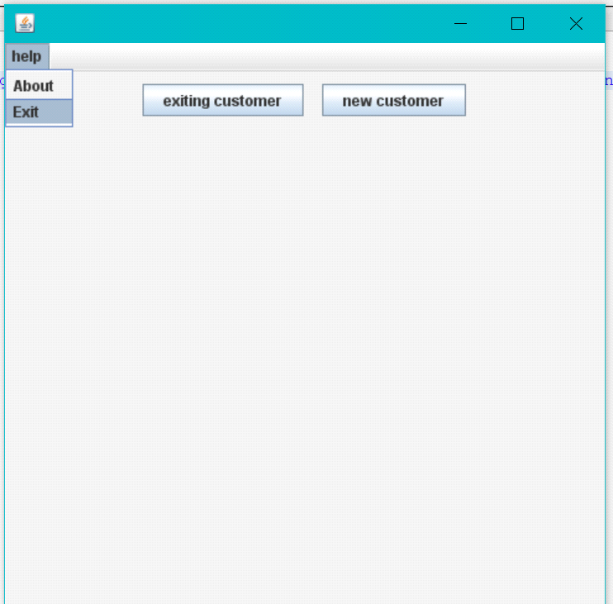

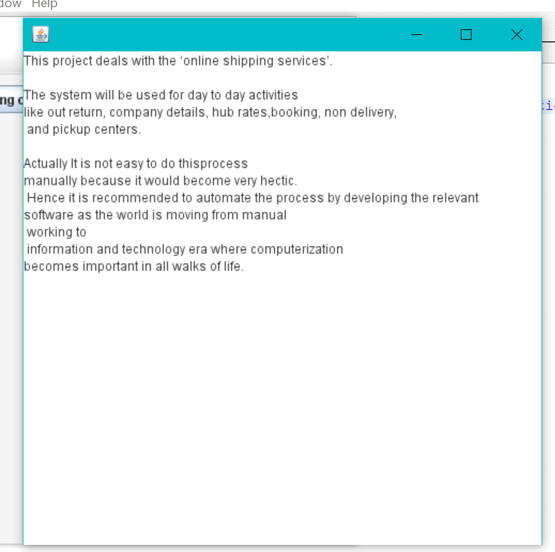

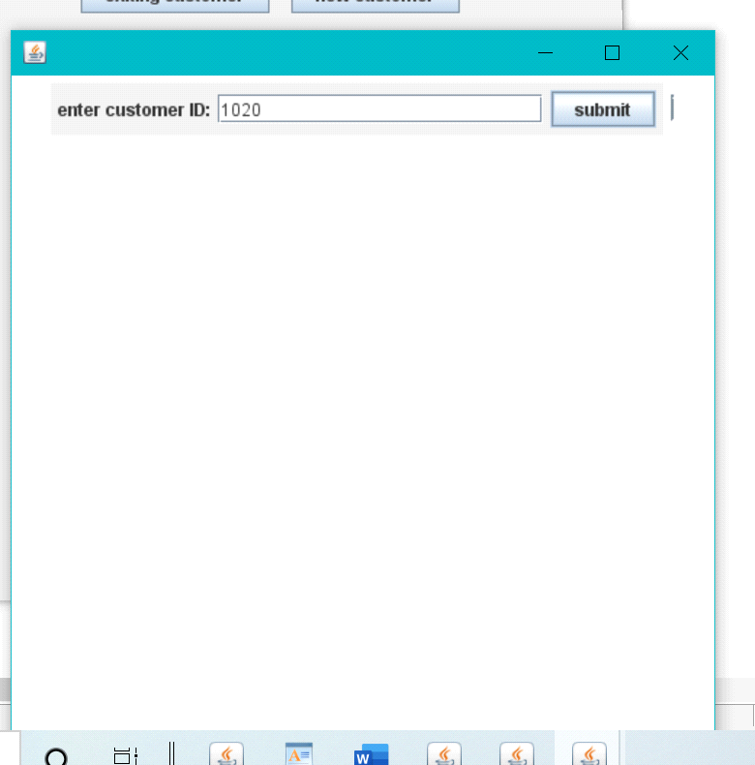

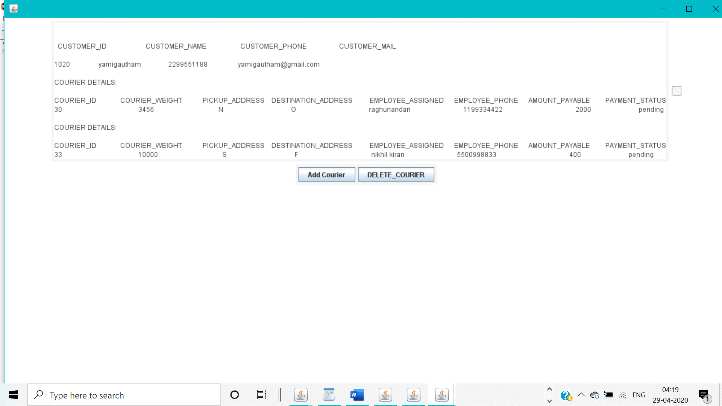

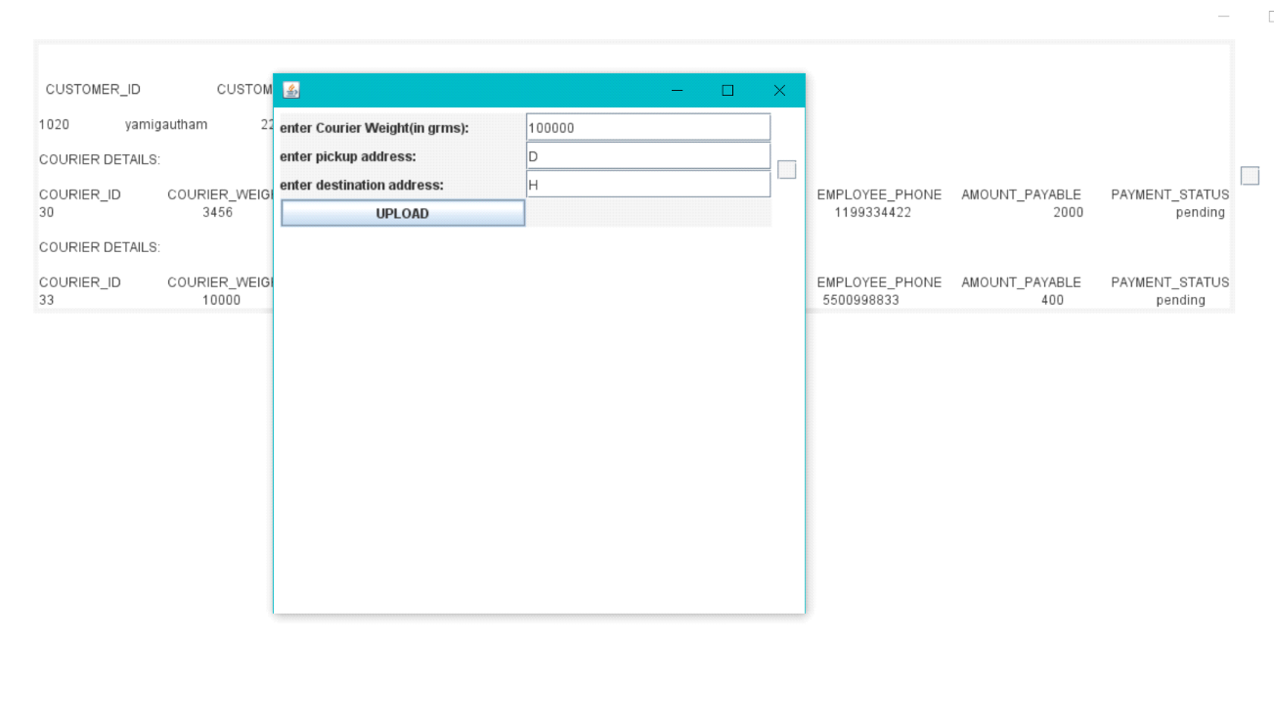

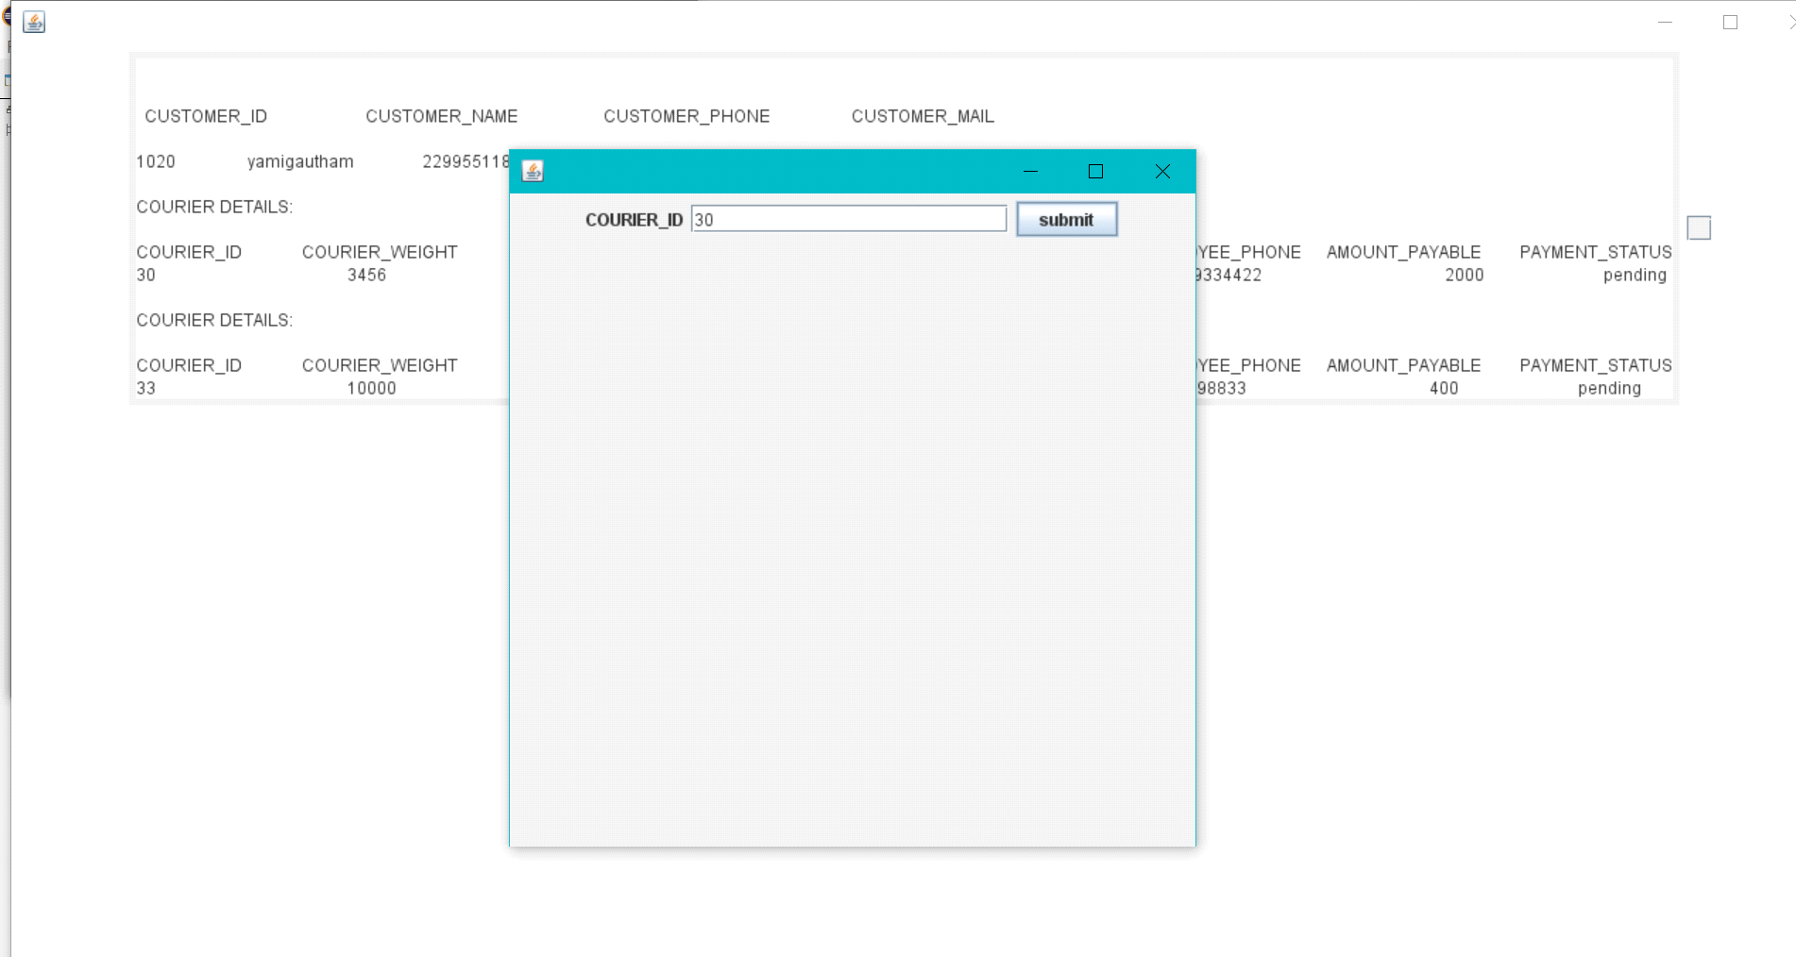

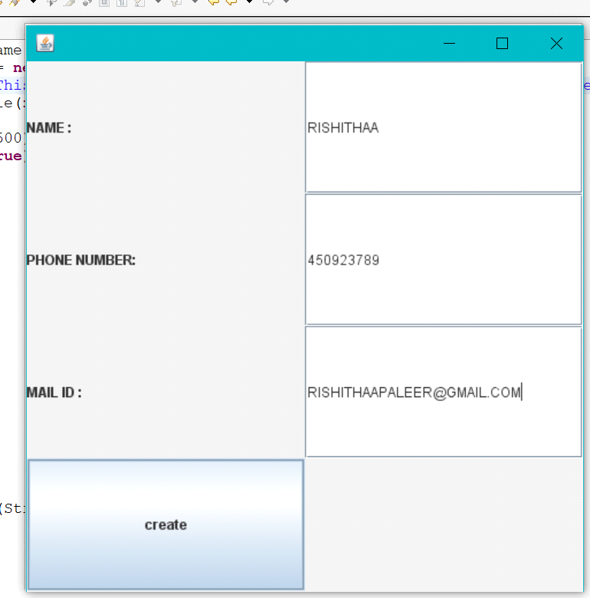

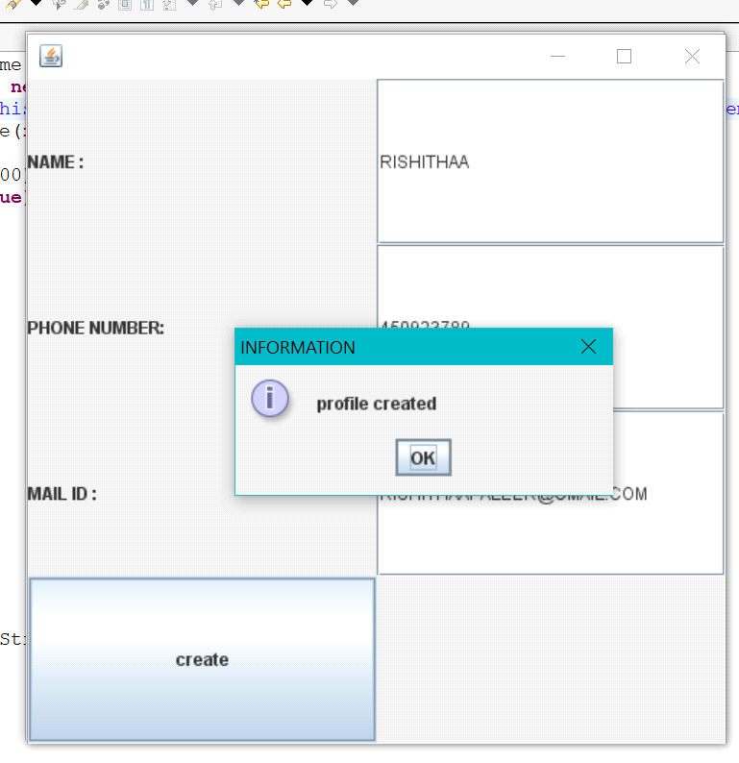

7 CONCLUSION:

In addition to the features mentioned, the proposed project on courier Management System is very flexible and can incorporate many new features and modules. Based on the user requirements, modifications to various parts of the system can be done for all the modules in the system.

NORMALIZATION

Customer : cust_id -> cust_name , cust_ph , cust_mail

Employee: emp_id -> emp_name , emp_ph , emp_mail

Courier: cou_id -> cou_weight , pickup_add , destin_add

Bookings: cou_id ,cust_id , emp_id

Payment : pay_id -> Amount , payment_status

Pays : cou_id , pay_id

**First Normal Form (1NF)**

For a table to be in the First Normal Form, it should follow the following 4 rules:

1.It should only have single(atomic) valued attributes/columns.

2.Values stored in a column should be of the same domain

3.All the columns in a table should have unique names.

4.And the order in which data is stored, does not matter.

**Second Normal Form (2NF)**

For a table to be in the Second Normal Form,

1.It should be in the First Normal form.

2.And, it should not have Partial Dependency.

**Third Normal Form (3NF)**

A table is said to be in the Third Normal Form when,

1.It is in the Second Normal form.

2.And, it doesn't have Transitive Dependency.

**Boyce and Codd Normal Form (BCNF)**

Boyce and Codd Normal Form is a higher version of the Third Normal form. This form deals with certain type of anomaly that is not handled by 3NF. A 3NF table which does not have multiple overlapping candidate keys is said to be in BCNF. For a table to be in BCNF, following conditions must be satisfied:

1.R must be in 3rd Normal Form

2.and, for each functional dependency ( X → Y ), X should be a super Key.

**Fourth Normal Form (4NF)**

A table is said to be in the Fourth Normal Form when,

1.It is in the Boyce-Codd Normal Form.

2.And, it doesn't have Multi-Valued Dependency.